ASSIGNMENT NO. 12

MINI PROJECT: Training Institute Management System

Objective: Develop a basic MySQL Training Institute Management System to manage students, trainers, courses, batches, enrollments, attendance, and assessment results.

Requirement Analysis
Main users:
  - Administrator — manages students, trainers, courses, batches and reports.
  - Trainer — manages attendance and assessment results.
  - Institute Coordinator — reviews batch, attendance, performance and enrollment reports.
Main functional requirements:
  - Maintain student and trainer information.
  - Maintain courses and batches.
  - Enroll students into batches.
  - Record attendance for enrollments.
  - Record assessment results.
  - Generate course, batch, attendance and performance reports.

Database Design and Table Relationships
Parent Table | Related Table | Relationship | Purpose
Course | Batch | One-to-Many | One course can have multiple batches.
Trainer | Batch | One-to-Many | One trainer can handle multiple batches.
Student | Enrollment | One-to-Many | One student can have multiple enrollments.
Batch | Enrollment | One-to-Many | One batch can contain multiple enrollments.
Enrollment | Attendance | One-to-Many | One enrollment can have multiple attendance records.
Enrollment | AssessmentResult | One-to-Many | One enrollment can have multiple  assessment results.

Basic ER Diagram

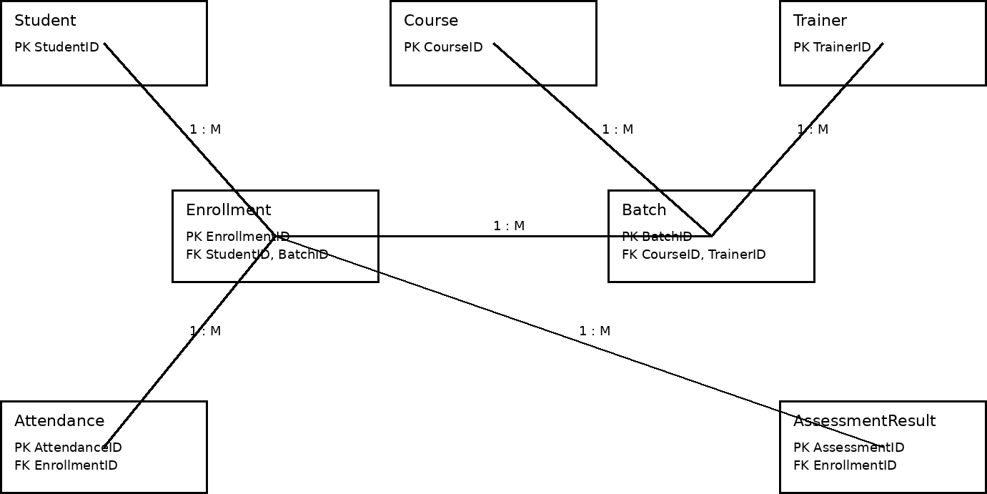

Database Creation and Table Structure

CREATE DATABASE TrainingInstituteDB_Assignment_12;

USE TrainingInstituteDB_Assignment_12;

Student Table

CREATE TABLE Student (

StudentID INT PRIMARY KEY,

StudentName VARCHAR(50) NOT NULL,

Email VARCHAR(80),

City VARCHAR(30)

);

Trainer Table

CREATE TABLE Trainer (

TrainerID INT PRIMARY KEY,

TrainerName VARCHAR(50) NOT NULL,

Specialization VARCHAR(50),

Email VARCHAR(80)

);

Course Table

CREATE TABLE Course (

CourseID INT PRIMARY KEY,

CourseName VARCHAR(50) NOT NULL,

DurationMonths INT NOT NULL,

Fees DECIMAL(10,2) NOT NULL

);

Batch Table

CREATE TABLE Batch (

BatchID INT PRIMARY KEY,

BatchName VARCHAR(50) NOT NULL,

CourseID INT NOT NULL,

TrainerID INT NOT NULL,

StartDate DATE NOT NULL,

EndDate DATE,

FOREIGN KEY (CourseID) REFERENCES Course(CourseID),

FOREIGN KEY (TrainerID) REFERENCES Trainer(TrainerID)

);

Enrollment Table

CREATE TABLE Enrollment (

EnrollmentID INT PRIMARY KEY,

StudentID INT NOT NULL,

BatchID INT NOT NULL,

EnrollmentDate DATE NOT NULL,

FOREIGN KEY (StudentID) REFERENCES Student(StudentID),

FOREIGN KEY (BatchID) REFERENCES Batch(BatchID)

);

Attendance Table

CREATE TABLE Attendance (

AttendanceID INT PRIMARY KEY,

EnrollmentID INT NOT NULL,

SessionDate DATE NOT NULL,

Status ENUM('Present', 'Absent') NOT NULL,

FOREIGN KEY (EnrollmentID) REFERENCES Enrollment(EnrollmentID)

);

AssessmentResult Table

CREATE TABLE AssessmentResult (

AssessmentID INT PRIMARY KEY,

EnrollmentID INT NOT NULL,

AssessmentName VARCHAR(50) NOT NULL,

Score DECIMAL(5,2) NOT NULL,

AssessmentDate DATE NOT NULL,

FOREIGN KEY (EnrollmentID) REFERENCES Enrollment(EnrollmentID)

);

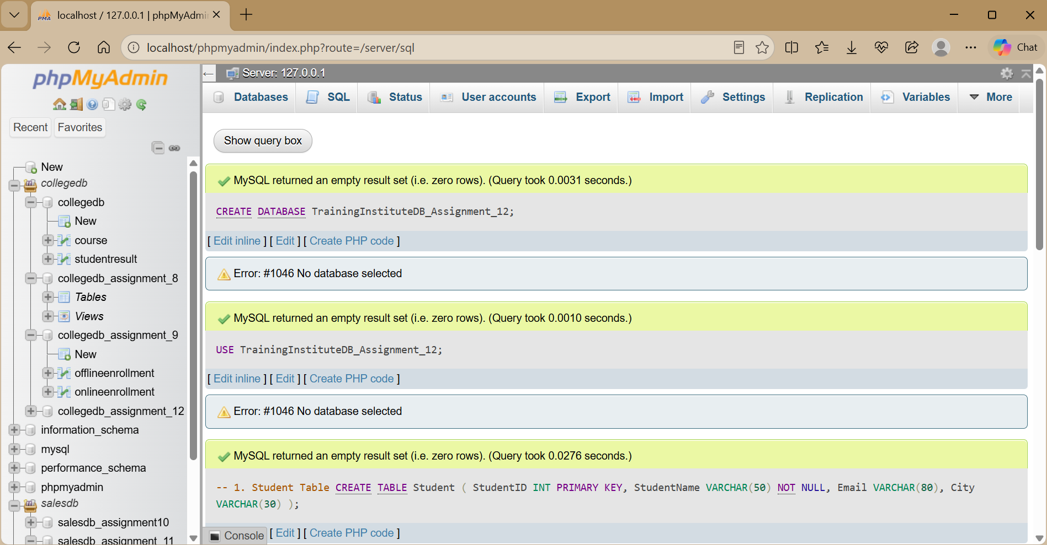

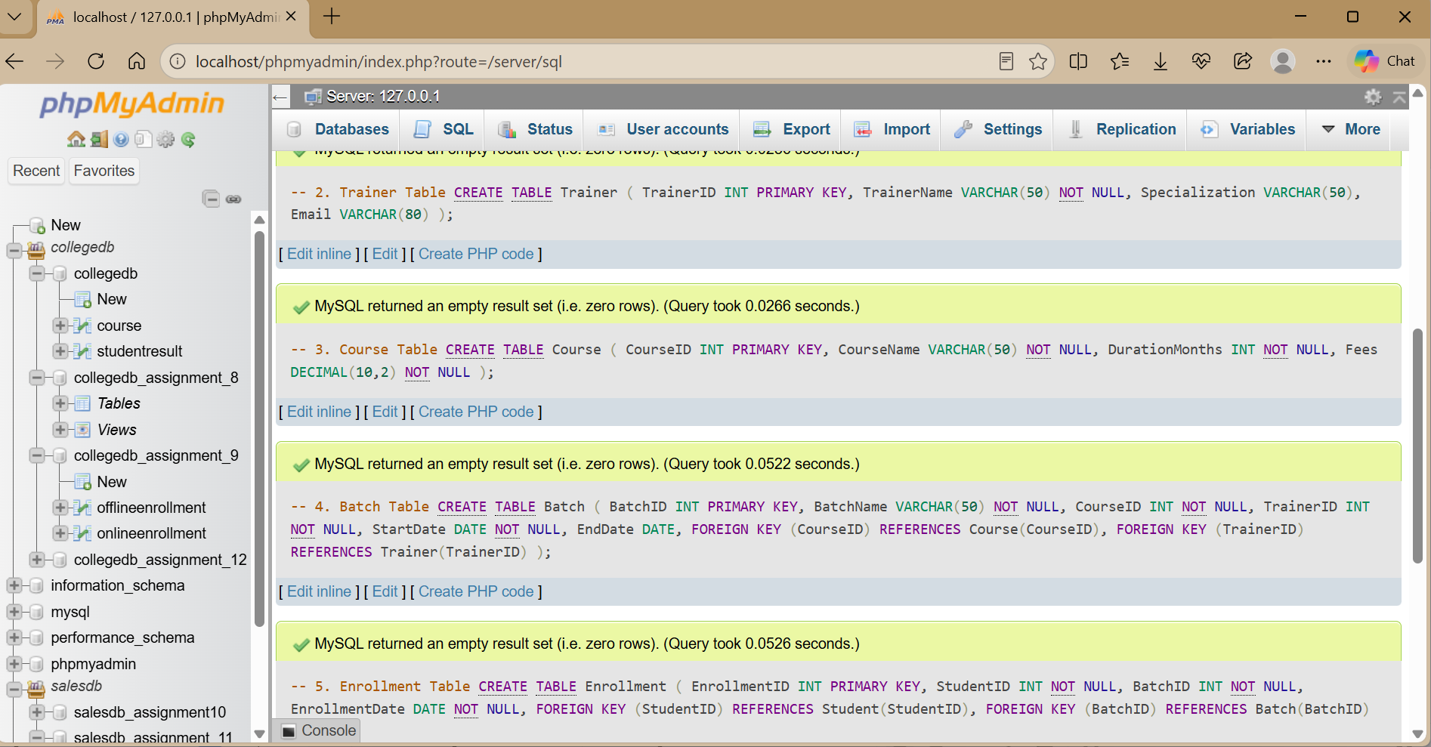

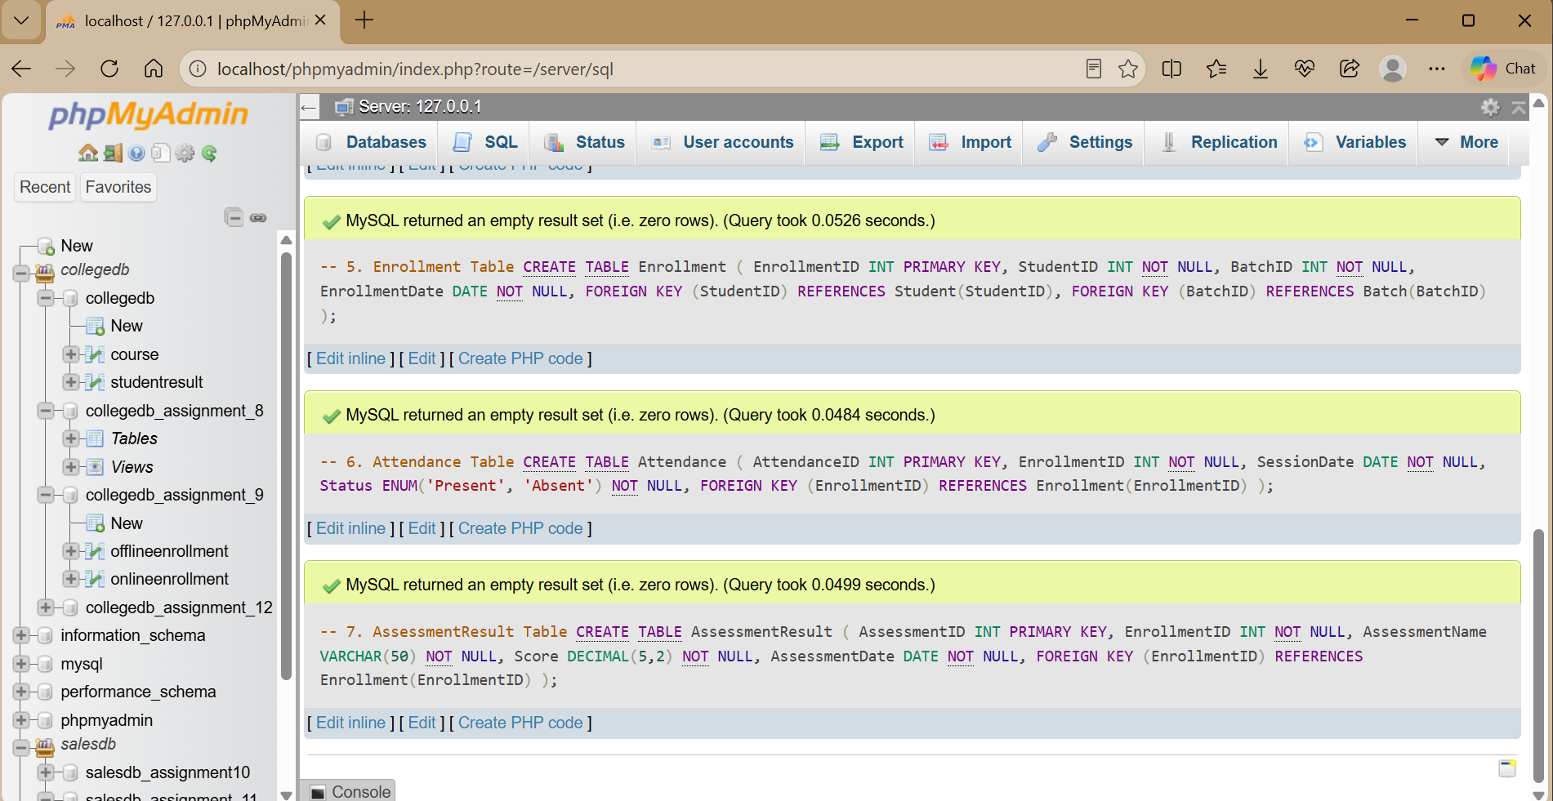

Sample Data

INSERT INTO Student VALUES
(1, 'Rahul Sharma', 'rahul@gmail.com', 'Mumbai'),
(2, 'Priya Patil', 'priya@gmail.com', 'Pune'),
(3, 'Aman Verma', 'aman@gmail.com', 'Nashik'),
(4, 'Sneha Joshi', 'sneha@gmail.com', 'Mumbai'),
(5, 'Karan Mehta', 'karan@gmail.com', 'Thane'),
(6, 'Neha Shah', 'neha@gmail.com', 'Pune');

INSERT INTO Trainer VALUES
(101, 'Amit Kulkarni', 'SQL and Database Management', 'amit@training.com'),
(102, 'Pooja Desai', 'Python and Data Science', 'pooja@training.com'),
(103, 'Rohan Mehta', 'Web Development', 'rohan@training.com');

INSERT INTO Course VALUES
(201, 'SQL and Database Management', 3, 18000.00),
(202, 'Python for Data Science', 4, 25000.00),
(203, 'Web Development', 4, 22000.00);

INSERT INTO Batch VALUES
(301, 'SQL-MAR-2026', 201, 101, '2026-03-01', '2026-05-31'),
(302, 'Python-MAR-2026', 202, 102, '2026-03-05', '2026-06-30'),
(303, 'Web-MAR-2026', 203, 103, '2026-03-10', '2026-07-10');

INSERT INTO Enrollment VALUES
(401, 1, 301, '2026-03-01'),
(402, 2, 301, '2026-03-01'),
(403, 3, 302, '2026-03-05'),
(404, 4, 302, '2026-03-05'),
(405, 5, 303, '2026-03-10'),
(406, 6, 301, '2026-03-01');

INSERT INTO Attendance VALUES
(501, 401, '2026-03-10', 'Present'),
(502, 401, '2026-03-17', 'Present'),
(503, 402, '2026-03-10', 'Absent'),
(504, 402, '2026-03-17', 'Present'),
(505, 403, '2026-03-10', 'Present'),
(506, 403, '2026-03-17', 'Present'),
(507, 404, '2026-03-10', 'Absent'),
(508, 404, '2026-03-17', 'Absent'),
(509, 405, '2026-03-12', 'Present'),
(510, 405, '2026-03-19', 'Present'),
(511, 406, '2026-03-10', 'Present'),
(512, 406, '2026-03-17', 'Absent');

INSERT INTO AssessmentResult VALUES
(601, 401, 'SQL Test', 88.00, '2026-04-01'),
(602, 402, 'SQL Test', 76.00, '2026-04-01'),
(603, 403, 'Python Test', 92.00, '2026-04-05'),
(604, 404, 'Python Test', 68.00, '2026-04-05'),
(605, 405, 'Web Test', 84.00, '2026-04-10'),
(606, 406, 'SQL Test', 81.00, '2026-04-01');

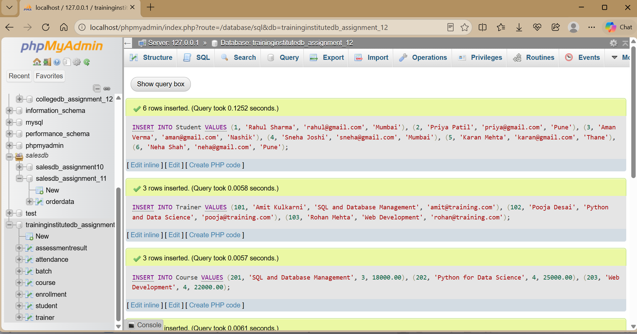

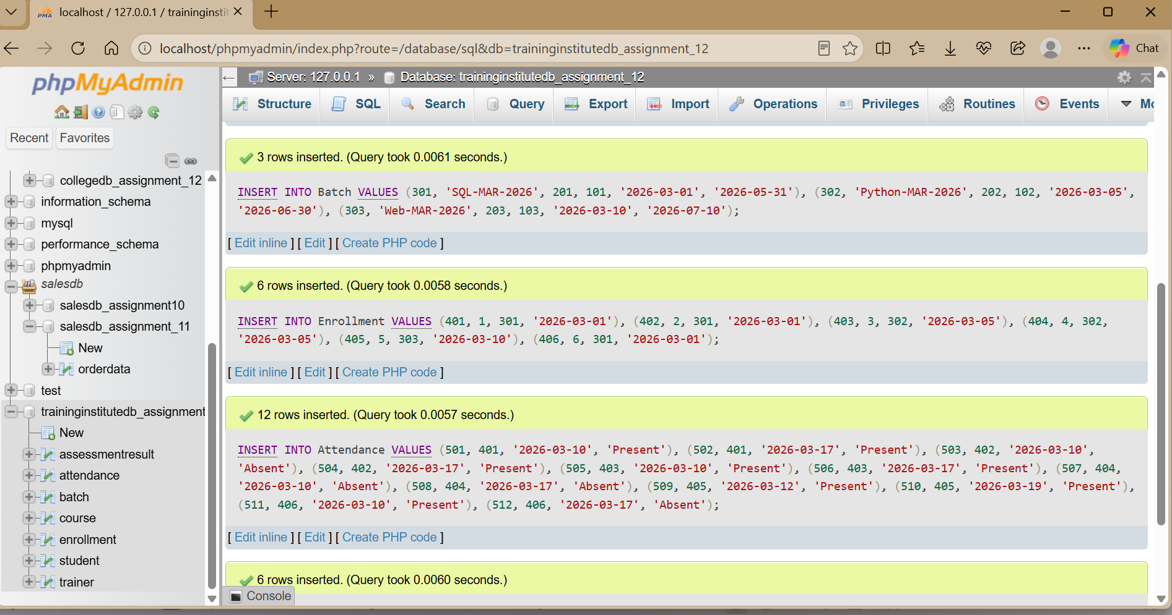

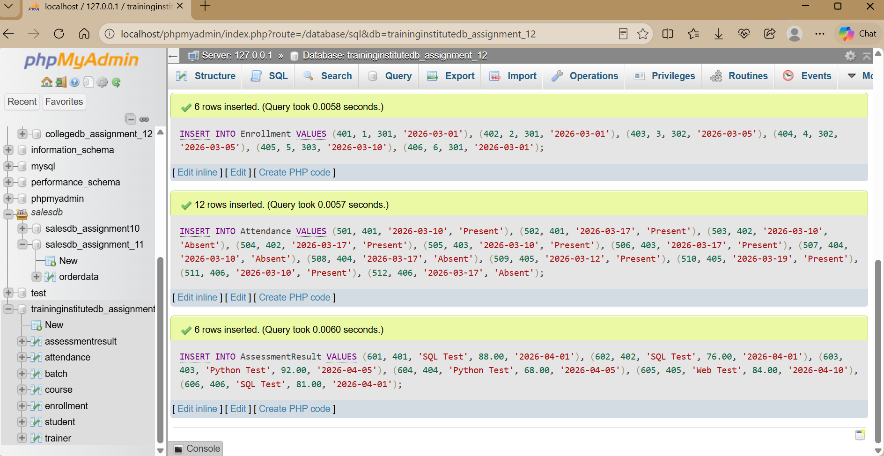

Business Queries and Data Analysis

Q1. Display all students enrolled in each batch.

SELECT
B.BatchName, S.StudentName
FROM Enrollment E
INNER JOIN Student S ON E.StudentID = S.StudentID INNER JOIN Batch B ON E.BatchID = B.BatchID ORDER BY B.BatchName, S.StudentName;

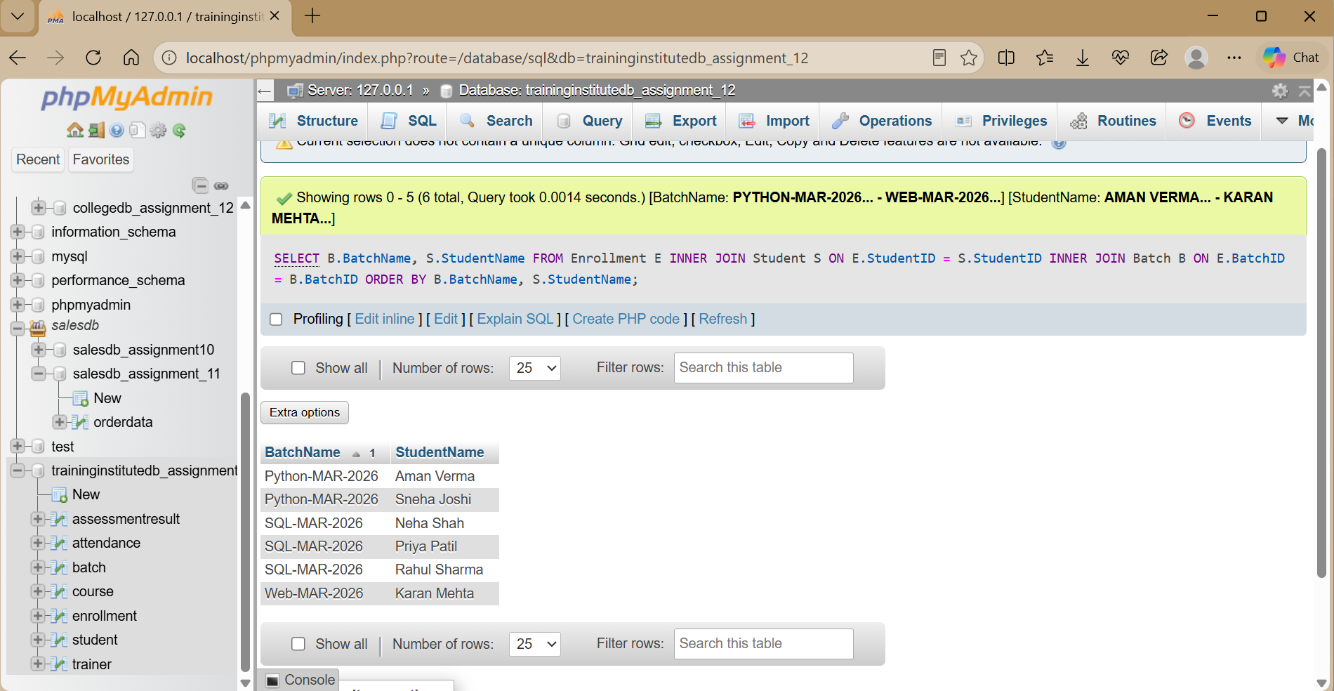

Q2. Display the course and trainer assigned to every batch.

SELECT
B.BatchName, C.CourseName, T.TrainerName
FROM Batch B
INNER JOIN Course C ON B.CourseID = C.CourseID INNER JOIN Trainer T ON B.TrainerID = T.TrainerID;

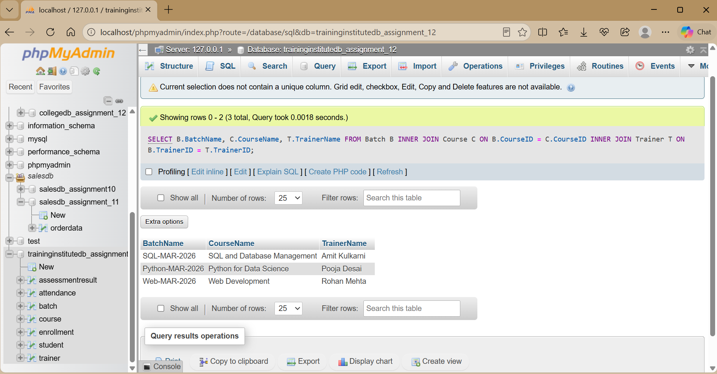

Q3. Find the total number of students in each course.

SELECT
C.CourseName,
COUNT(E.EnrollmentID) AS TotalStudents FROM Course C
LEFT JOIN Batch B ON C.CourseID = B.CourseID LEFT JOIN Enrollment E ON B.BatchID = E.BatchID GROUP BY C.CourseID, C.CourseName;

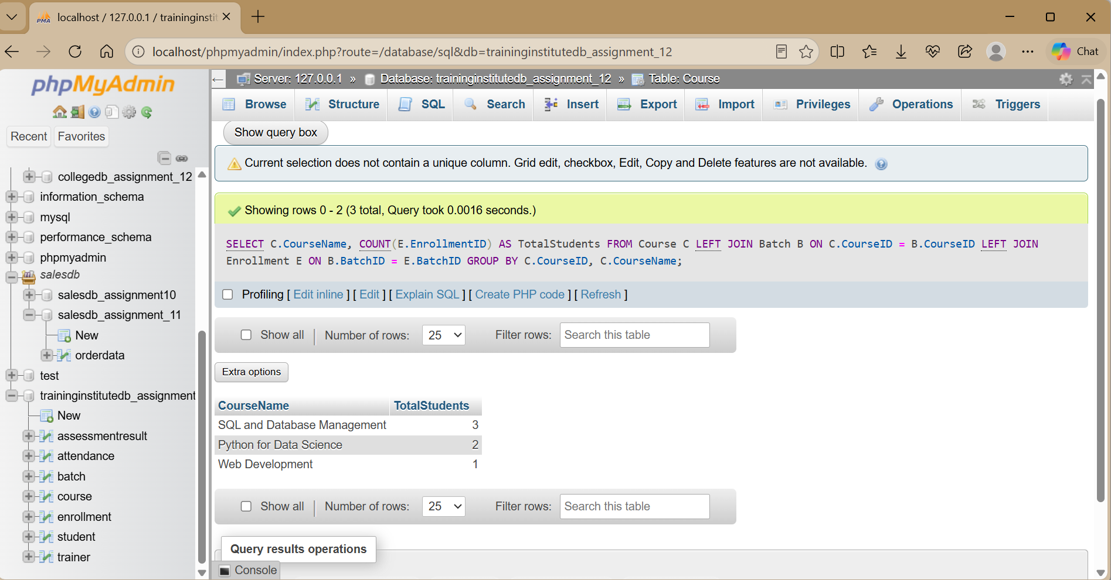

Q4. Find batches having more than a specified number of students.

SELECT
B.BatchName,
COUNT(E.EnrollmentID) AS TotalStudents FROM Batch B
LEFT JOIN Enrollment E ON B.BatchID = E.BatchID GROUP BY B.BatchID, B.BatchName
HAVING COUNT(E.EnrollmentID) > 1;

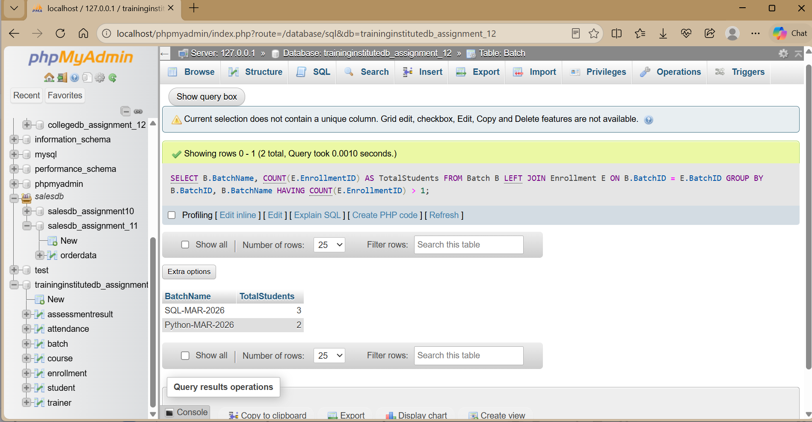
.

Q5. Display students whose attendance is below 75%.

SELECT
S.StudentName, ROUND(
100.0 * SUM(A.Status = 'Present') / COUNT(A.AttendanceID), 2
) AS AttendancePercentage FROM Student S
INNER JOIN Enrollment E ON S.StudentID = E.StudentID INNER JOIN Attendance A ON E.EnrollmentID = A.EnrollmentID GROUP BY S.StudentID, S.StudentName
HAVING AttendancePercentage < 75;

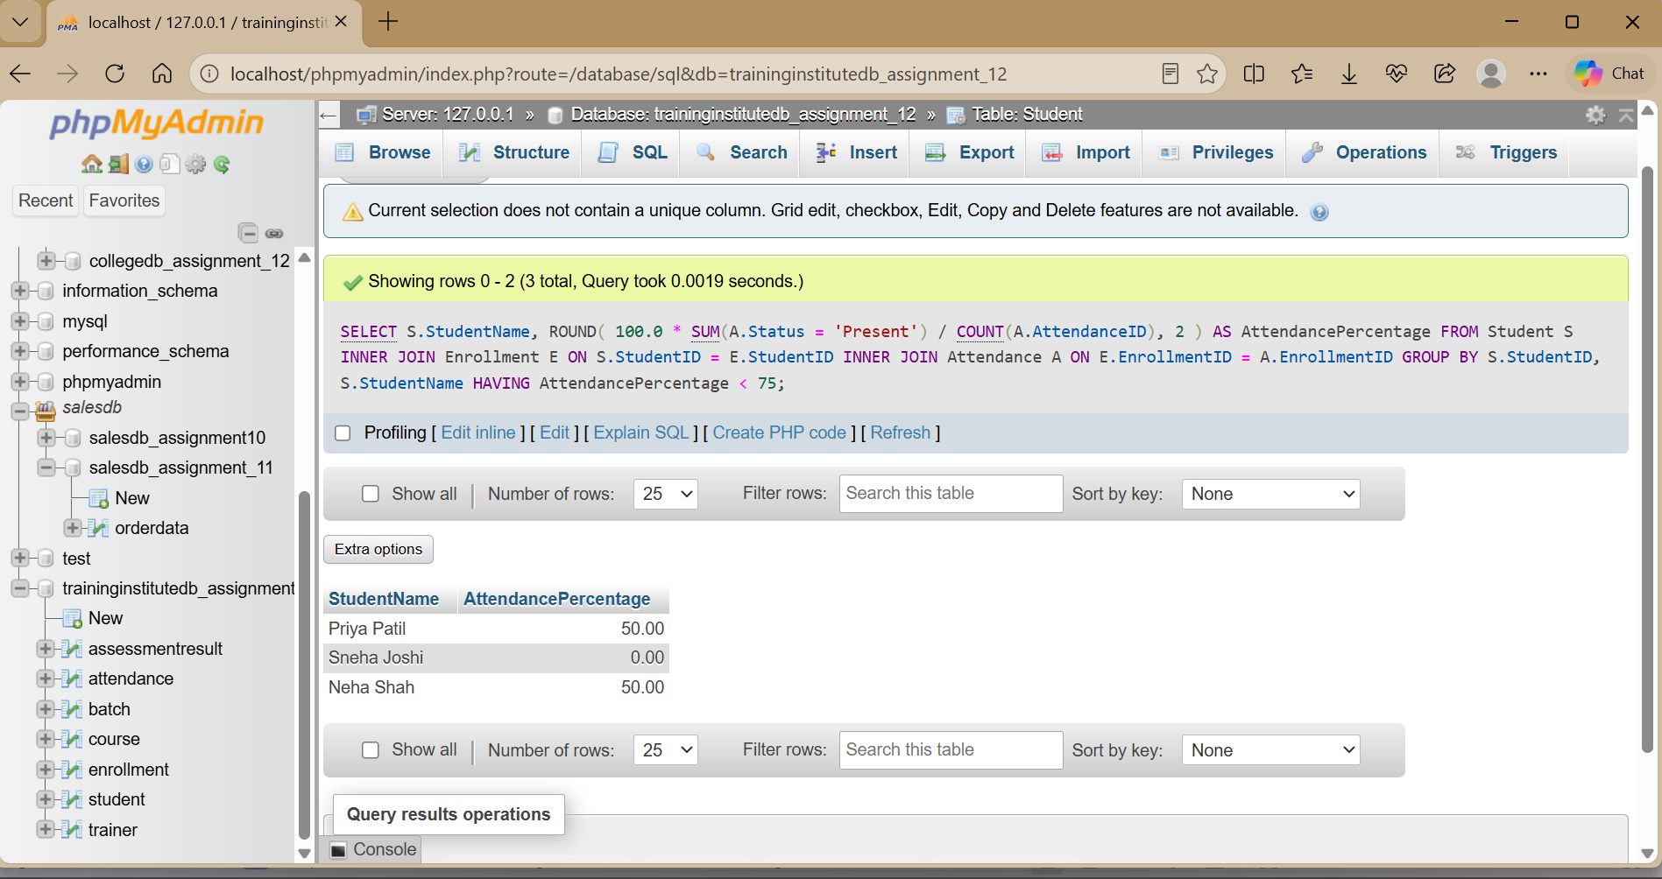

Q6. Find the average assessment score for each batch.

SELECT
B.BatchName,
ROUND(AVG(A.Score), 2) AS AverageScore FROM Batch B
INNER JOIN Enrollment E ON B.BatchID = E.BatchID
INNER JOIN AssessmentResult A ON E.EnrollmentID = A.EnrollmentID GROUP BY B.BatchID, B.BatchName;

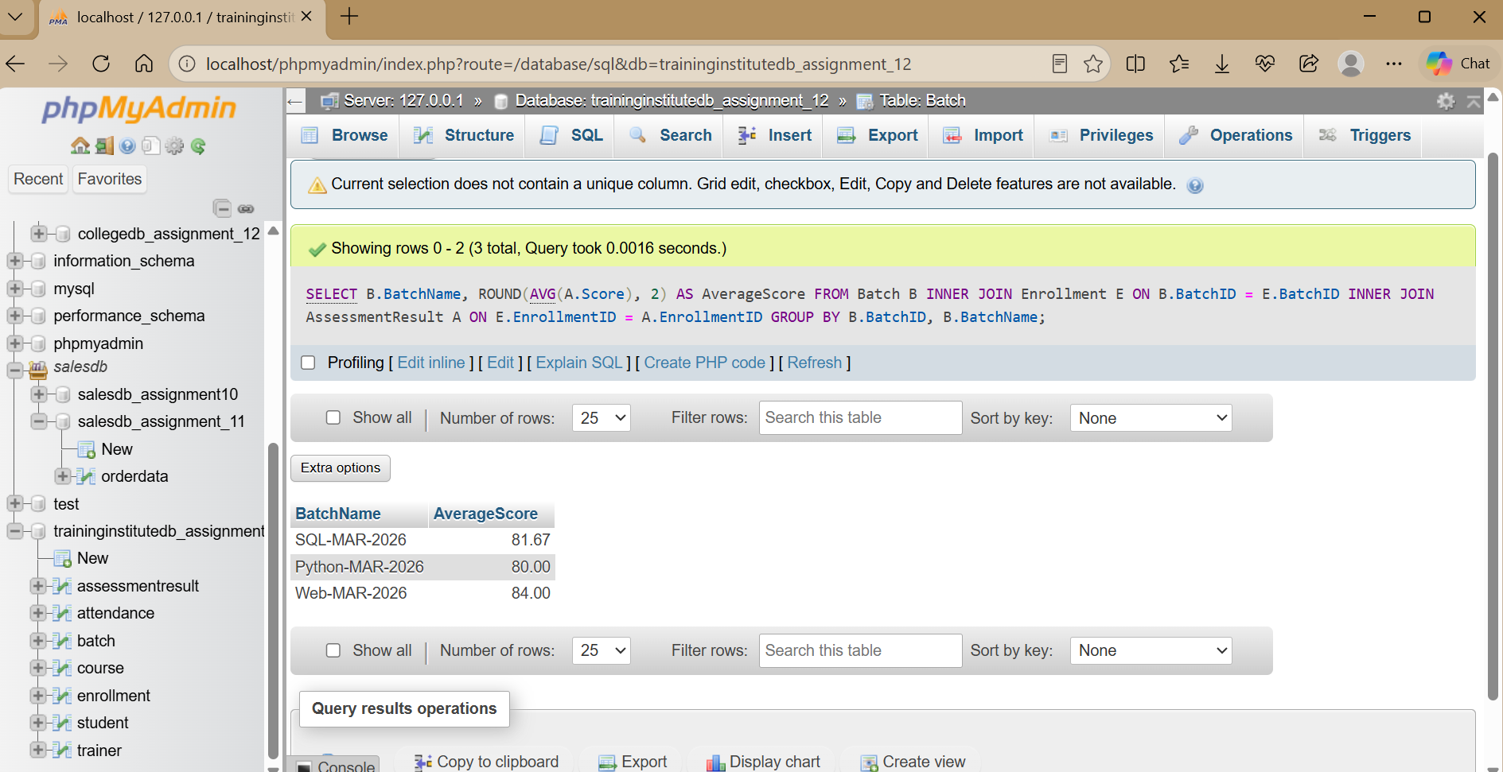

Q7. Identify the highest-performing student in every batch.

SELECT
BatchName, StudentName, Score
FROM (
SELECT
B.BatchName, S.StudentName, A.Score, ROW_NUMBER() OVER (
PARTITION BY B.BatchID
ORDER BY A.Score DESC, S.StudentID
) AS RowNum
FROM AssessmentResult A
INNER JOIN Enrollment E ON A.EnrollmentID = E.EnrollmentID INNER JOIN Student S ON E.StudentID = S.StudentID
INNER JOIN Batch B ON E.BatchID = B.BatchID
) AS RankedStudents WHERE RowNum = 1;

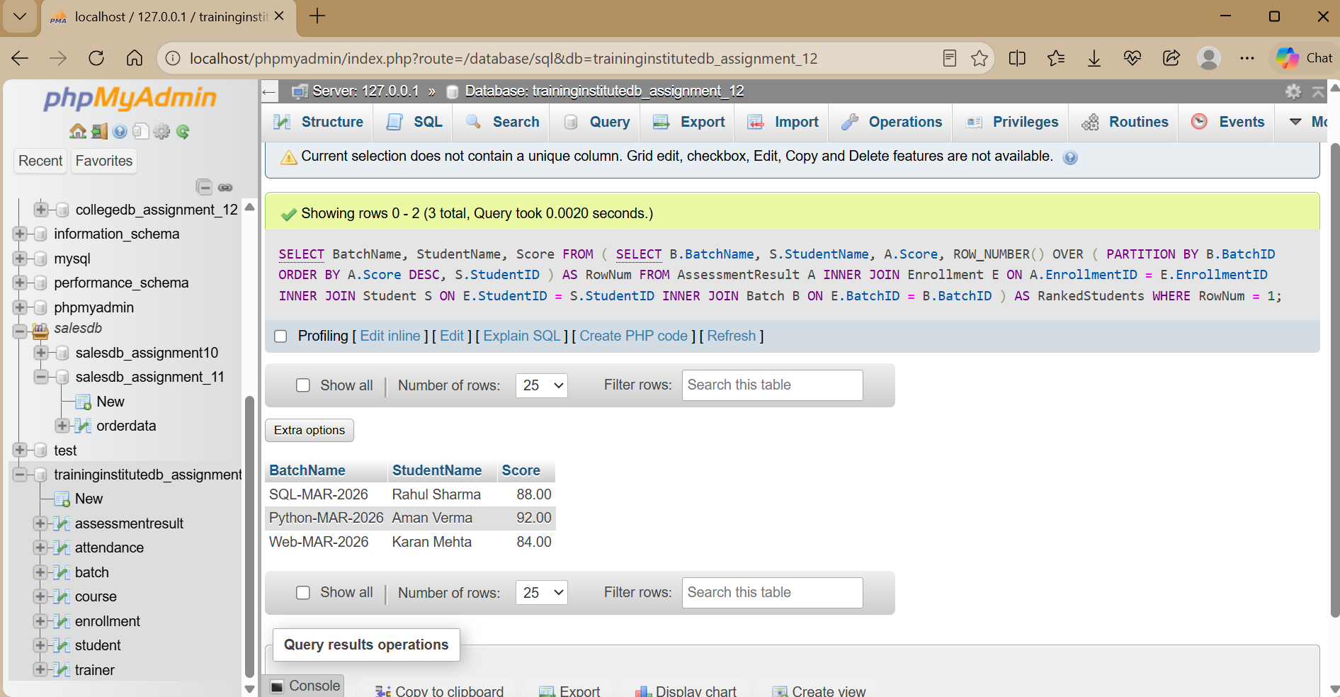

Q8. Display students who have not attended any session.

SELECT
S.StudentID, S.StudentName
FROM Student S WHERE NOT EXISTS (
SELECT 1
FROM Enrollment E INNER JOIN Attendance A
ON E.EnrollmentID = A.EnrollmentID WHERE E.StudentID = S.StudentID
);

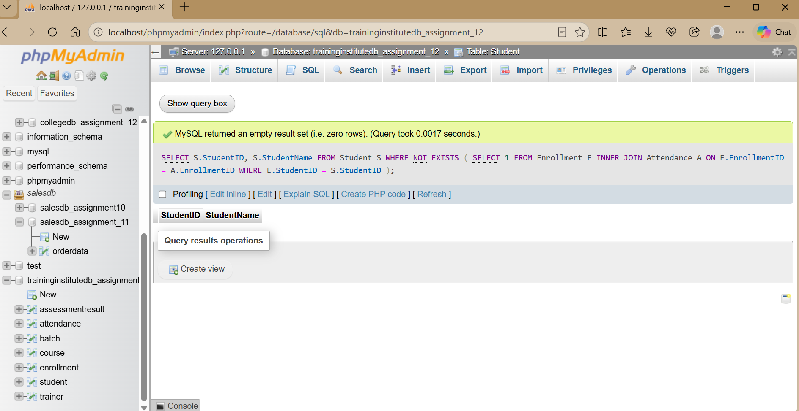

Q9. Compare course-wise student performance.

SELECT
C.CourseName,
COUNT(DISTINCT E.StudentID) AS TotalStudents,
ROUND(AVG(A.Score), 2) AS AverageScore
FROM Course C
LEFT JOIN Batch B ON C.CourseID = B.CourseID
LEFT JOIN Enrollment E ON B.BatchID = E.BatchID
LEFT JOIN AssessmentResult A ON E.EnrollmentID = A.EnrollmentID
GROUP BY C.CourseID, C.CourseName;

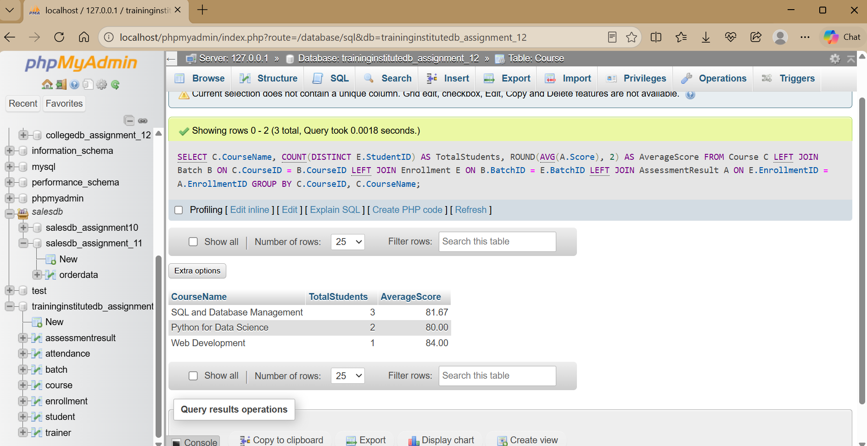

Q10. Rank students according to assessment results.

SELECT
S.StudentName, B.BatchName, A.Score, RANK() OVER (
ORDER BY A.Score DESC
) AS OverallRank FROM AssessmentResult A
INNER JOIN Enrollment E ON A.EnrollmentID = E.EnrollmentID INNER JOIN Student S ON E.StudentID = S.StudentID

INNER JOIN Batch B ON E.BatchID = B.BatchID;

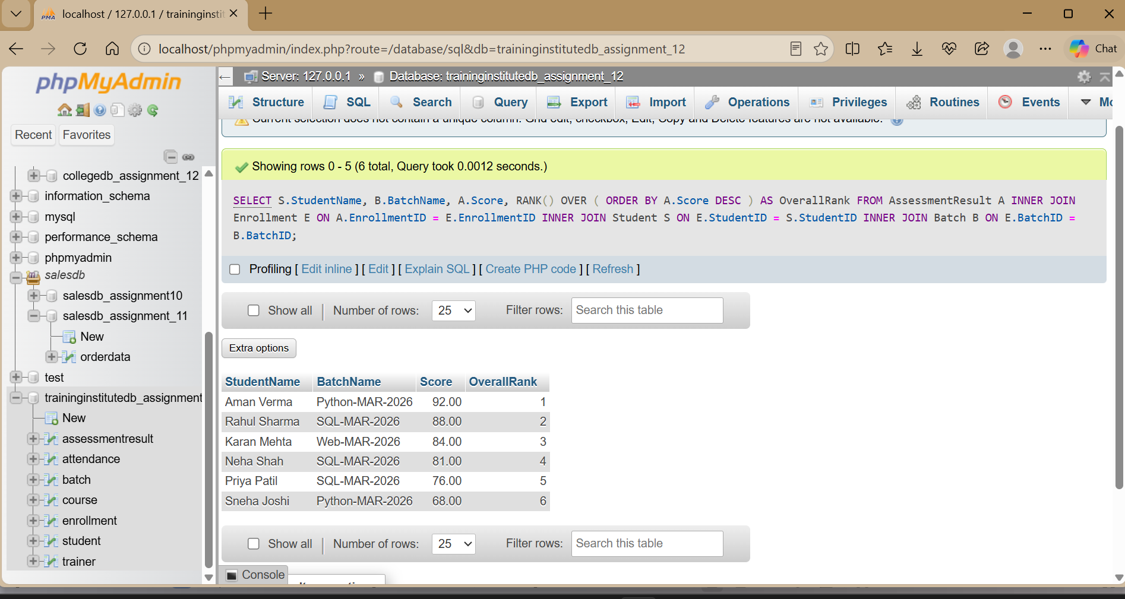

Q11. Find batches with the highest and lowest average attendance.

SELECT
B.BatchName, ROUND(
100.0 * SUM(A.Status = 'Present') / COUNT(A.AttendanceID), 2
) AS AttendancePercentage FROM Batch B
INNER JOIN Enrollment E ON B.BatchID = E.BatchID
INNER JOIN Attendance A ON E.EnrollmentID = A.EnrollmentID GROUP BY B.BatchID, B.BatchName
ORDER BY AttendancePercentage DESC;

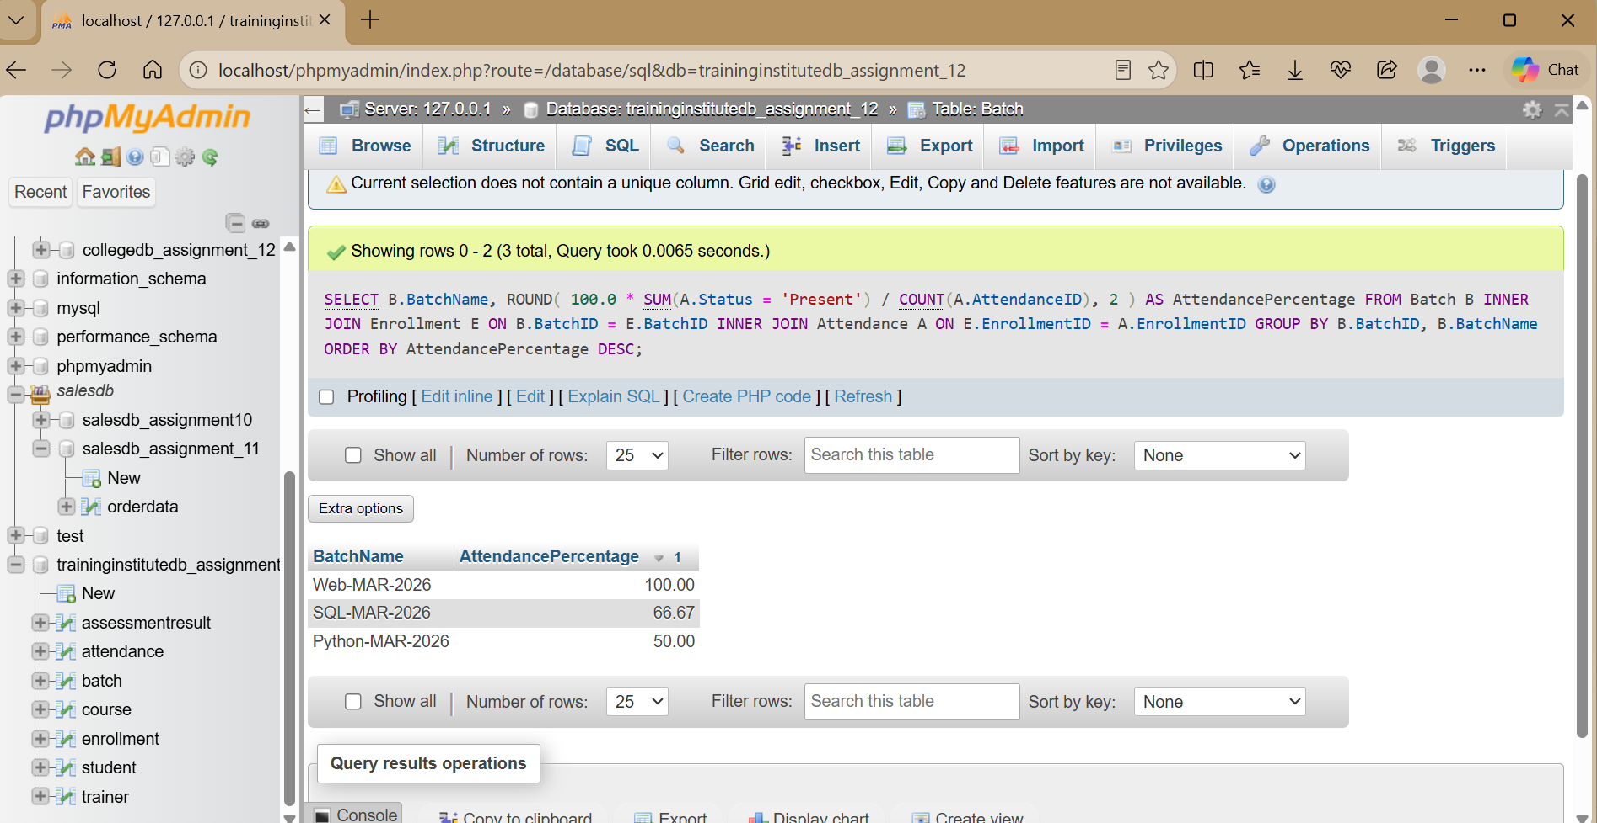
The first row represents the highest attendance percentage and the last row represents the lowest, after the result is ordered.

Q12. Generate a student-wise training progress report.

SELECT
S.StudentName, C.CourseName, B.BatchName, ROUND(
100.0 * SUM(A.Status = 'Present') / COUNT(A.AttendanceID), 2
) AS AttendancePercentage,
ROUND(AVG(R.Score), 2) AS AverageAssessmentScore FROM Student S
INNER JOIN Enrollment E ON S.StudentID = E.StudentID INNER JOIN Batch B ON E.BatchID = B.BatchID
INNER JOIN Course C ON B.CourseID = C.CourseID
LEFT JOIN Attendance A ON E.EnrollmentID = A.EnrollmentID
LEFT JOIN AssessmentResult R ON E.EnrollmentID = R.EnrollmentID GROUP BY S.StudentID, S.StudentName, C.CourseName, B.BatchName;

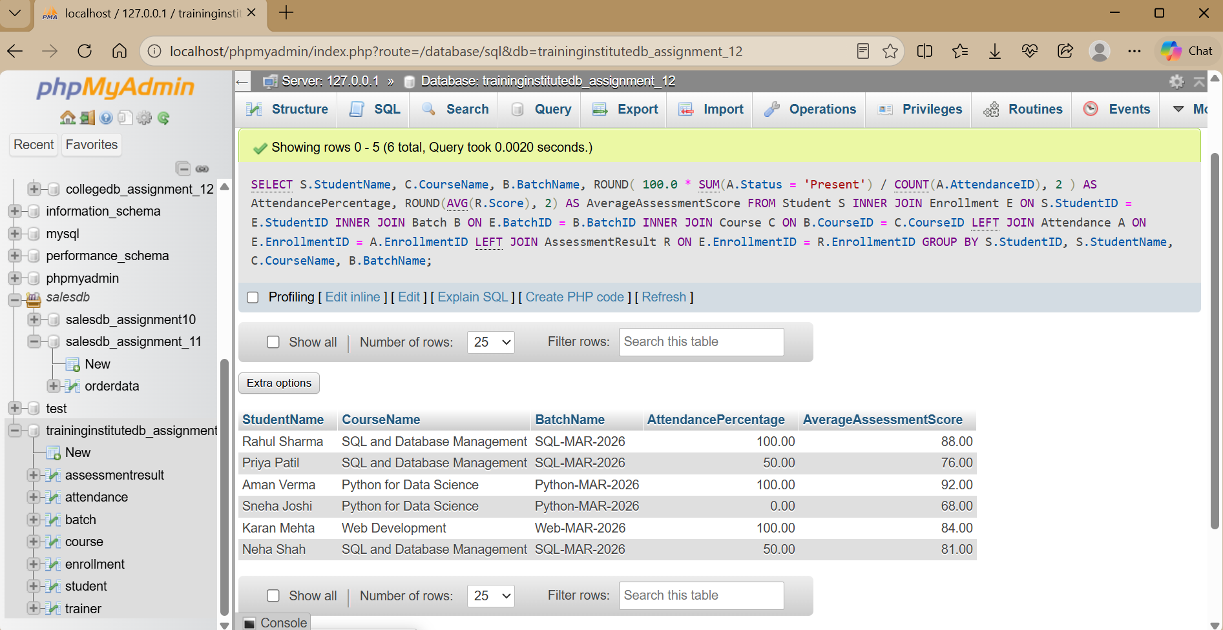

Useful View for Management Reporting

CREATE VIEW StudentProgressView AS SELECT
S.StudentID, S.StudentName, C.CourseName,
B.BatchName, ROUND(
100.0 * SUM(A.Status = 'Present') / COUNT(A.AttendanceID), 2
) AS AttendancePercentage,
ROUND(AVG(R.Score), 2) AS AverageAssessmentScore FROM Student S
INNER JOIN Enrollment E ON S.StudentID = E.StudentID INNER JOIN Batch B ON E.BatchID = B.BatchID
INNER JOIN Course C ON B.CourseID = C.CourseID
LEFT JOIN Attendance A ON E.EnrollmentID = A.EnrollmentID
LEFT JOIN AssessmentResult R ON E.EnrollmentID = R.EnrollmentID GROUP BY S.StudentID, S.StudentName, C.CourseName, B.BatchName;

SELECT * FROM StudentProgressView;

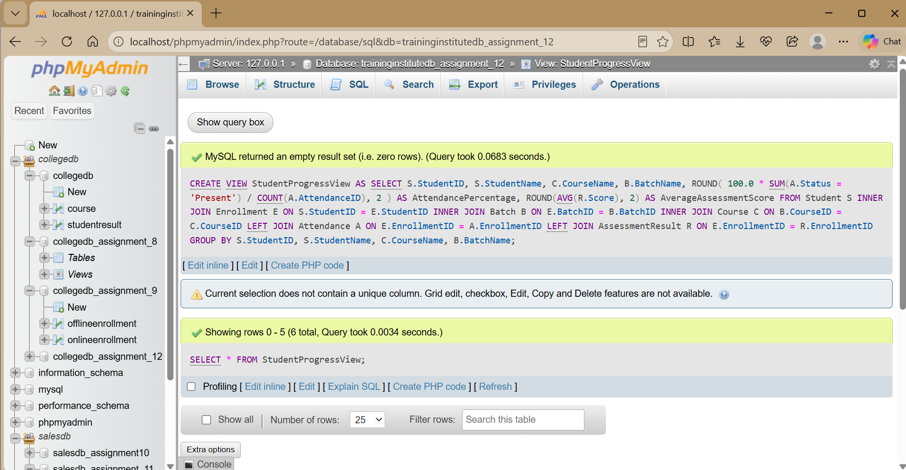

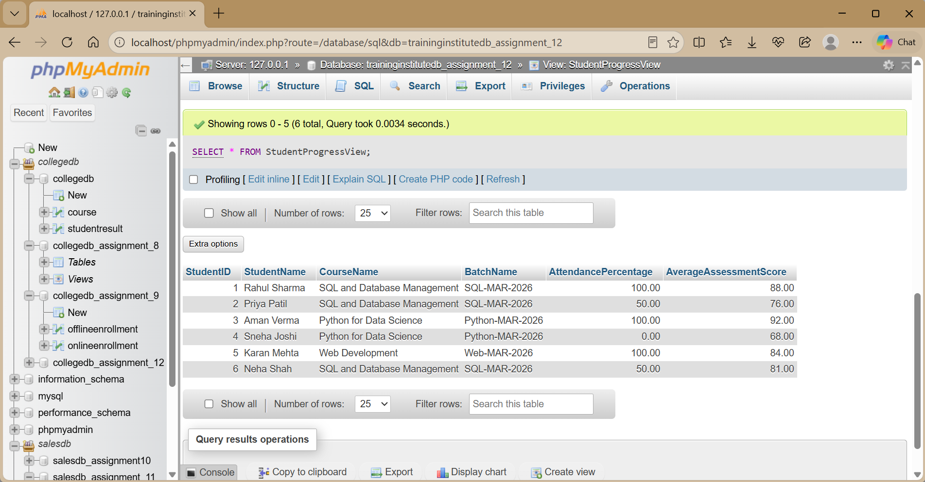

The view provides a reusable student progress report without rewriting the complete join and aggregation query.

Project Insights
  - Identify courses with the highest student enrollment using COUNT().
  - Identify batches with low attendance using attendance percentage and HAVING.
  - Identify high-performing students using AVG(), RANK(), or ROW_NUMBER().
  - Compare course performance using average assessment scores.
  - Use the reports to identify areas requiring additional training or student support.

Final Project Submission
  - ER diagram and table relationships.
  - MySQL script containing database creation, tables, constraints, sample data, and queries.
  - Query outputs in clear table format.
  - Short report containing objective, relationships, analysis, insights, and conclusion.
  - Brief explanation of the important business queries.

